**Vortices: Interaction, Creation, and Forms**

**The Wavetable Project**

From Pirates of the Caribbean to the mythical Greek creature Charybdis, whirlpools, vortices, and hurricanes have been painted as massive forces of nature. They are depicted swallowing ships whole, and reigning terror on seafarers, while in reality, they are only shadows of what literature and pop culture would have you believe.

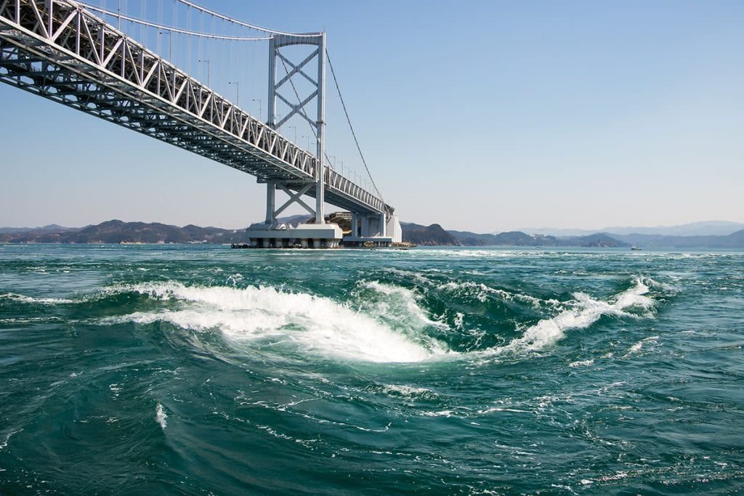

**Fig 1.** One of the world's largest maelstroms, in the Strait of Naruto in Japan. [1]

They are oceanic phenomena, strong enough only to endanger small vessels, caused by strong opposing currents and/or currents interacting with geographic obstacles. Today we will apply the ideas from the Fluid Rigidity lab to the real world as we simulate the formation and interaction of vortices.

**Before you begin, you will need:**

1. Wavetable
   1. With a RECTANGULAR tank
2. Food dye
3. Turkey baster
   1. OPTIONAL: Shop vacuum

**Safety:**

1. Keep all exposed wires away from the water tank
2. Keep all long hair tied back and away from any spinning parts of the setup

## Experiment 1

1. **Fill up the tank halfway with tap water and place it on the turntable. Then increase the rotation speed to set 0.5 and wait for solid-body rotation to be achieved (see the** [**Fluid Rigidity**](https://docs.google.com/document/d/1HXV1oUcAbuO4C6pveRZTnG69X9HgT7Pn903m76pLsds/edit#) **lab).**

But before we dive any further into the lab, we should properly define some of the terms we will be using as they correspond to very similar phenomena.

* Whirlpool
  + A rotating parcel of water.
* Vortex
  + A whirlpool with downdraft/force pulling the water down from the surface.
* Maelstroms
  + Are generally defined as larger whirlpools formed in seas or oceans while smaller whirlpools found in ponds, streams, and bathtubs are not. It is important to note that maelstroms can have a powerful downdraft like a vortex, and can also be thought of as oceanic vortices too, but are usually referenced otherwise. “The term maelstrom is commonly thought to derive from the Dutch verb *malen* (Nordic *male*) meaning ‘to grind’. The first written account is probably by Olaus Magnus (1490-1558), a Swedish bishop in Rome.” [2]
* Hurricane
  + Wind causes warm ocean water to evaporate, rise, and condense into large water droplets. These water droplets form cumulonimbus clouds. As more and more water evaporates and condenses, the wind begins to circulate, gathering more clouds, until it becomes a tropical disturbance, with a column of thunderstorm clouds.

1. **Once solid body rotation has been achieved, take your turkey baster and draw out some water from the tank. Do this by placing the turkey baster NEAR but not in a corner of the tank and quickly sucking some of the tank water into the baster. Then add a few drops of food dye to the same region to better visualize the phenomena.** *Note: This step can also be done using a shop vacuum to remove the top layer of water. If taking this approach be careful not to suck too much water into the vacuum as it could cause it to malfunction and/or break.*

Sketch a picture of what it looks like:

|  |
| --- |

*Please read:*

Let’s dive even further into the mechanisms behind hurricane formation.

As clouds are continually inducted into the thunderstorm cloud column, the clouds on top begin to cool, while the clouds on the bottom continue to warm. The cooling of the clouds— or the condensation of water vapor—into water droplets on top causes the upper levels to increase in density. The increase in density, high in the cloud column, causes the air/cloud at the top to descend into the low-pressure eye—or low-pressure, center—of the hurricane. As the heavy, dense air from the top of the column starts to sink down, the air at the bottom of the column attempts to move up—not only because the heat causes it to rise, but to equalize the pressure difference as well. This is a tropical depression.

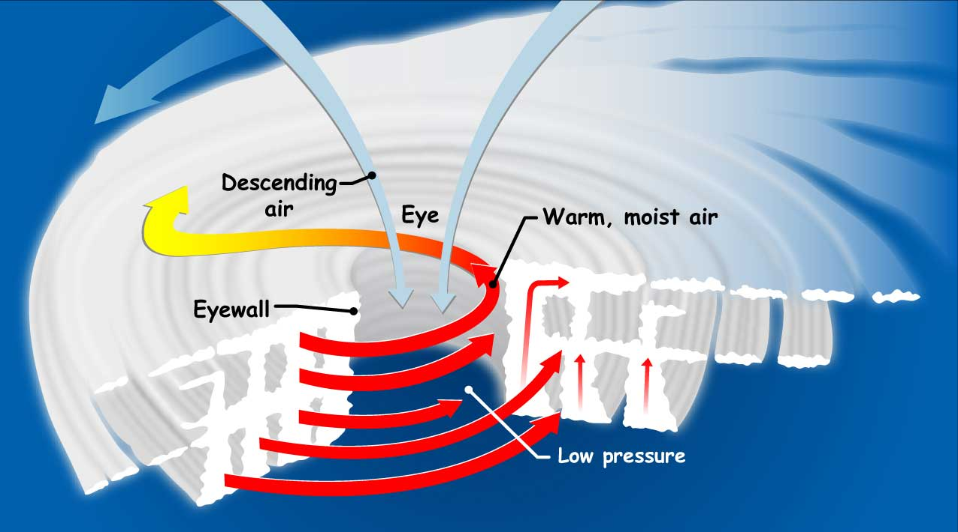

**Figure 1.** Depicting the two separate flows of hot and cold air, with the former spiraling upwards around the outside, and the latter descending back through the eye of the hurricane. [4]

As this cycle of this convection current continues, the rate of the air’s movement increases. As was mentioned earlier, the bands of upward trending, high-pressure air are spiraling in a certain direction. This spiraling is the same that causes the shape of the hurricanes to be twisted slightly and is caused by the Coriolis effect.

The Coriolis effect is an inertial force on a rotating object in relation to the inertial frame. In practice, this means that objects moving between latitudes are “deflected,” seemingly moved by an unknown force. Let’s consider this idea a bit further—imagine taking a horizontal cross section (slice) near one of the poles (1) and near the equator (2).

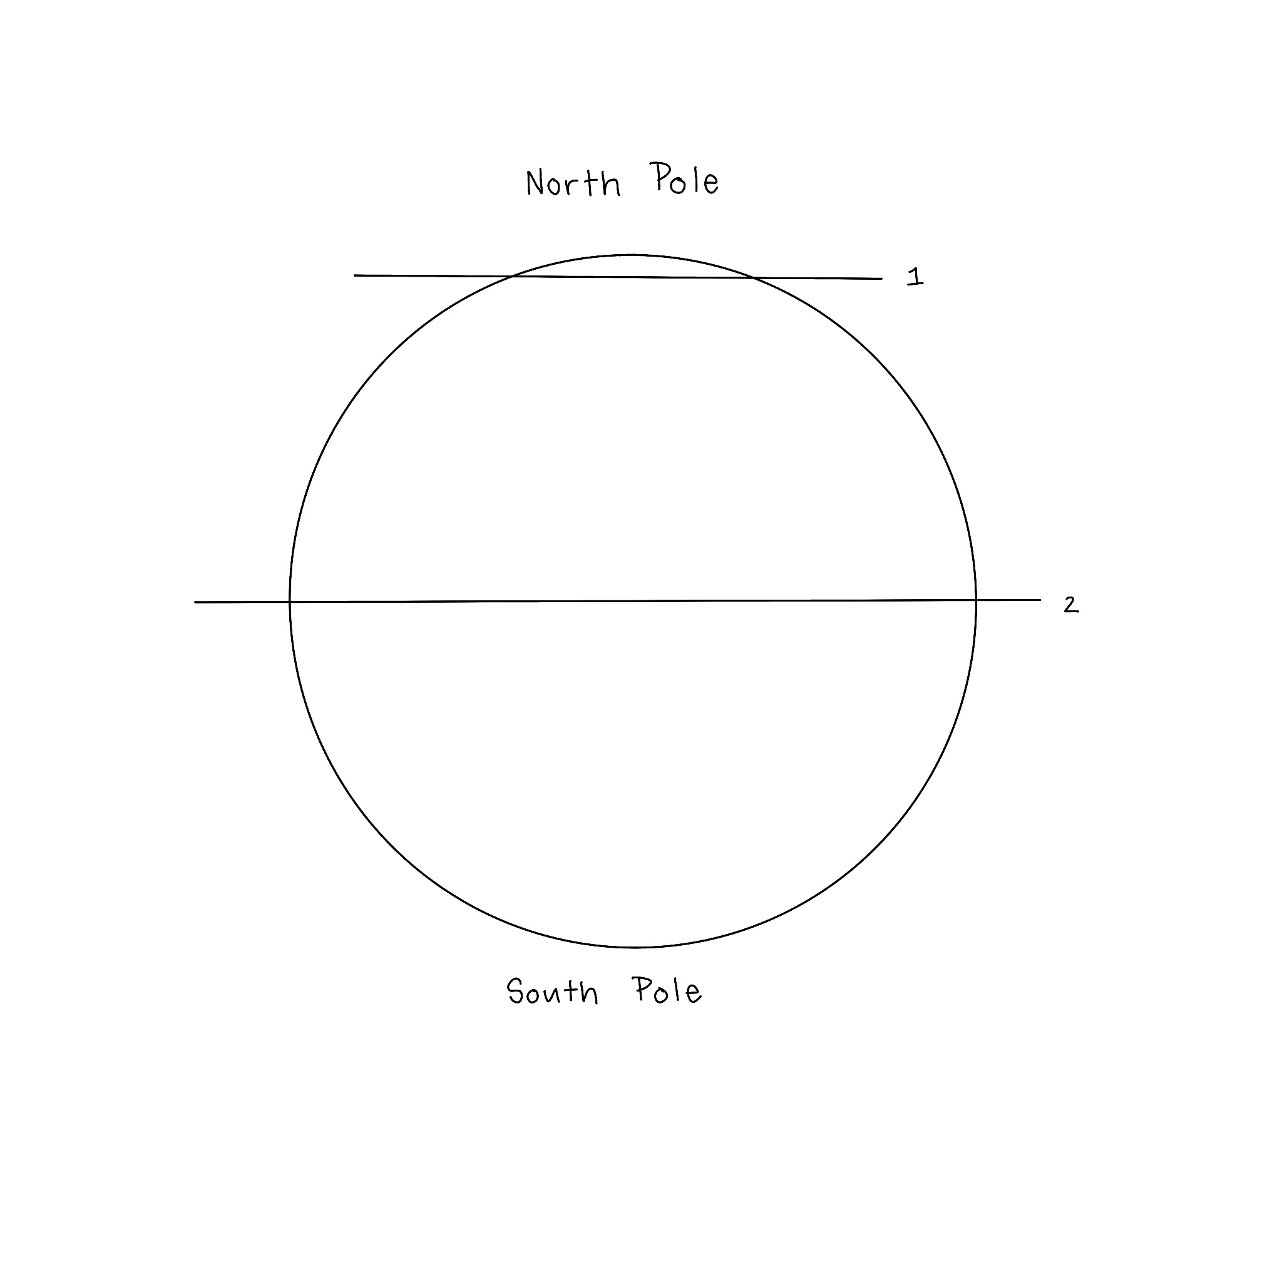

**Figure 2.** Diagram of earth, indicating aforementioned horizontal cross sections.

Both cross sections would result in circles, though the circles would be different sizes.

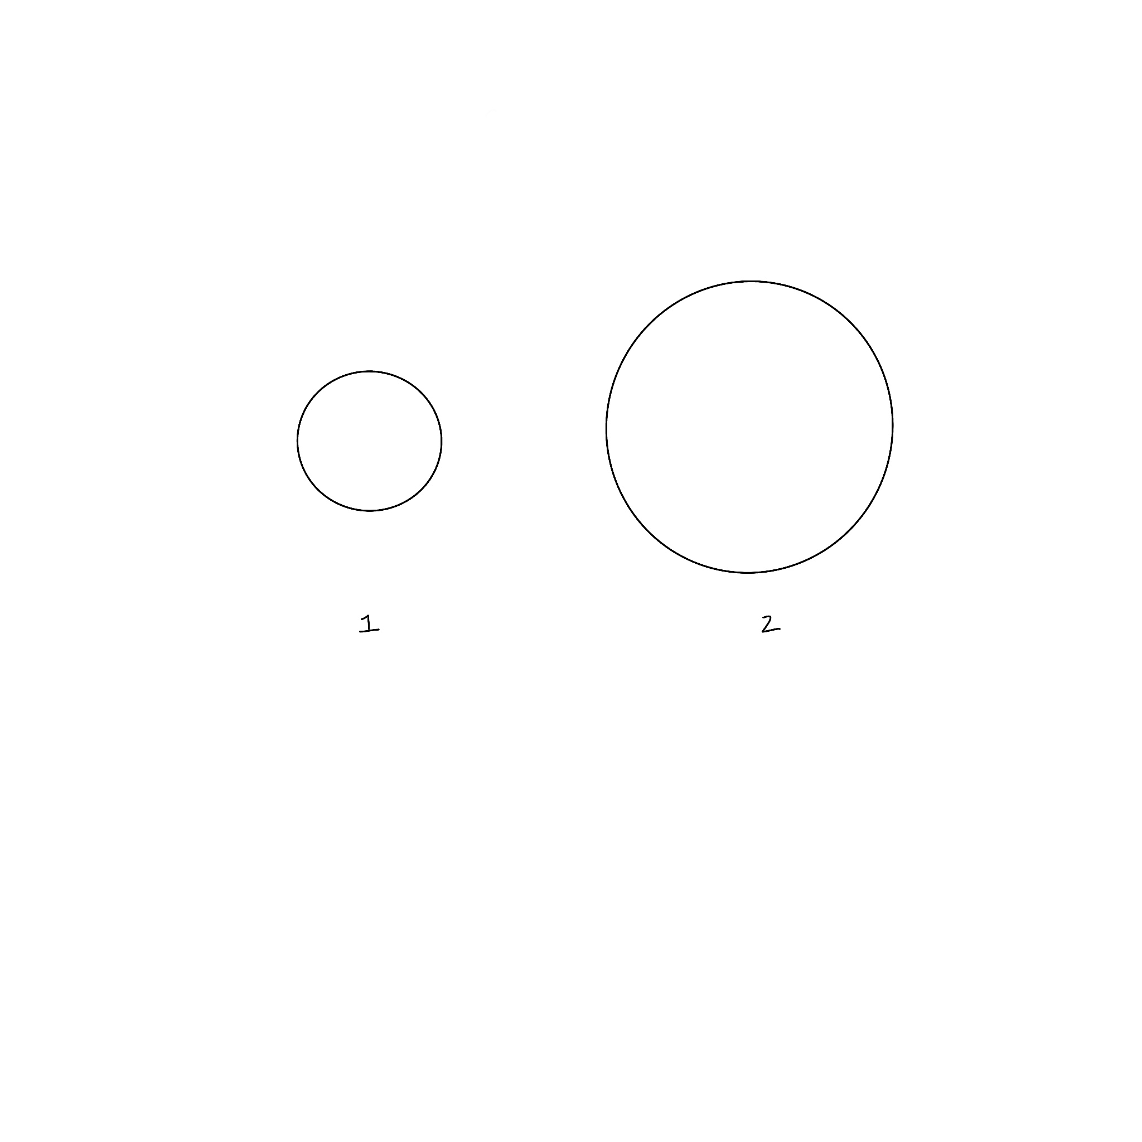

**Figure 3.** Horizontal cross sections of the earth at the poles (1) and equator (2).

The circumference of the circular cross section taken at the poles is much less than that of the cross section taken from the equator. Therefore, we know that the amount of distance that must be crossed in full rotation of earth is less at the poles than at the equator. We also know that one full rotation of earth takes the same amount of time at both the poles and the equator, since the earth completes one full rotation in one day. Speed is determined by how much distance may be covered in a given amount of time—given that time is constant, but distance decreases near the poles, it may be inferred that points near the equator move more quickly (with a higher speed) than those near the poles.

Because the equator travels more quickly than the poles, things traveling from the equator to the poles (or vice versa) experience a kind of “lag.” For example—if you could throw a ball from the north pole to the equator, you would expect it to travel straight down to the corresponding point on the equator. This path is shown below by the broken line in Figure 4. However, because the equator is rotating more quickly, the corresponding point on the equator will have actually already passed the ball by the time it lands. The result is a path where the ball looks like it’s curving backwards. This actual path is shown below in Figure 4 through the unbroken line.

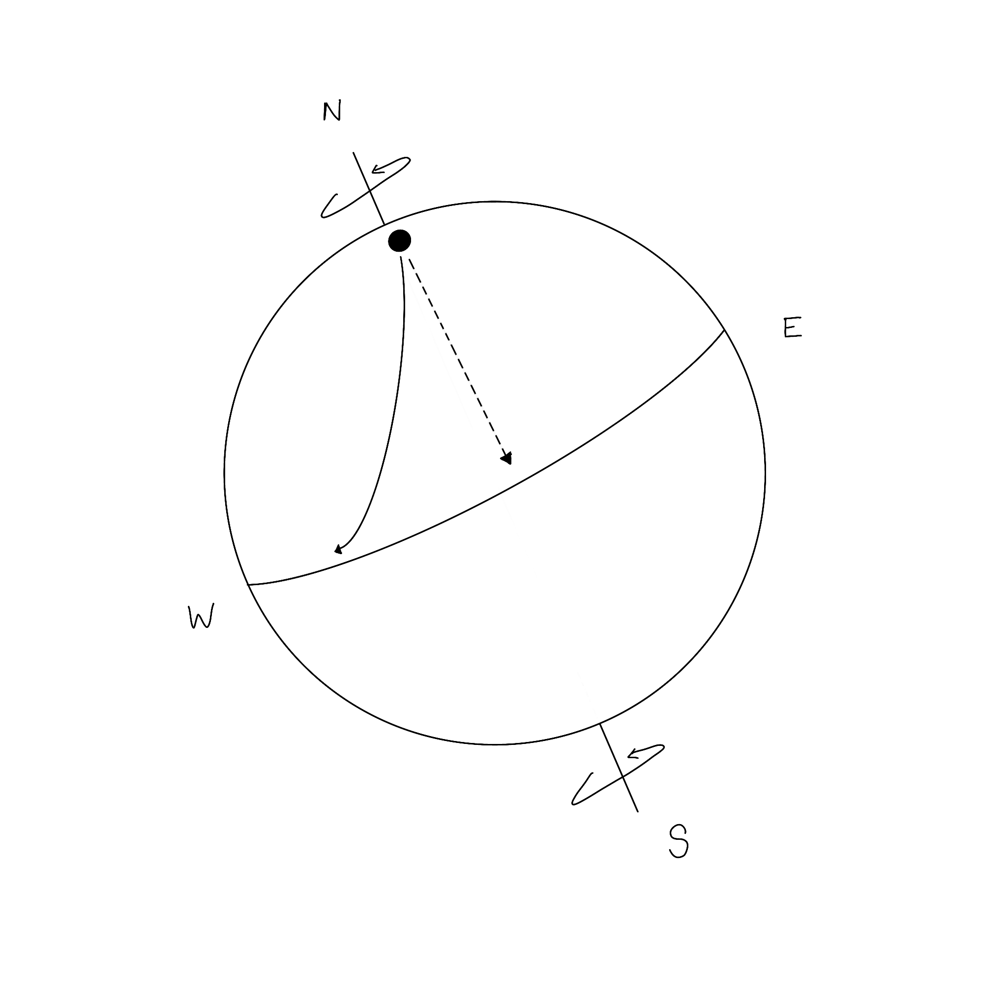

**Figure 4.** The path of a ball thrown from the north pole towards the equator. The expected path is shown by the broken line, while the actual path of the ball is shown by the unbroken line.

Similarly, if a ball were thrown from the equator to the north pole, it would land seemingly ahead of where it was “supposed” to land, because of the greater speed of the equator in comparison to the poles. This deflection of objects because of the different speeds of earth is the Coriolis effect. Just like a ball traveling from the equator to one of the poles, winds also experience deflection due to the Coriolis effect, which causes hurricanes to rotate clockwise in the Southern Hemisphere, and counterclockwise in the Northern Hemisphere.

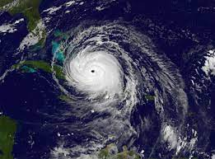

**Figure 5.** The spiral shape of a hurricane over the Caribbean was caused by the Coriolis force.

In this lab, a hurricane will be created inside the spinning environment of the tank — which is analogous to the earth's rotation. The food dye will be used to simply color the water, and make the hurricane easy to see. To simulate the tropical depression, an upwelling of high pressure, we will be using a shop vacuum or a turkey baster to remove the top layer of water. This simulates the hot ocean water that evaporates and rises, causing the hurricane. After some water has been sucked out by the turkey baster/shop vacuum, a vortex that looks akin to the above satellite image should appear.

1. **Let the water rest, and when the previous vortices have disappeared, create another vortex. Then, create another near it and wait for the two vortices to interact with one another. Before you do, however, make some predictions below:**

Will they bounce off of each other? Will they merge? Or will they simply cancel each other out and disappear?

|  |
| --- |

*Please read:*

Although they are not widely studied, it is generally accepted that there are two ways in which maelstroms usually form. Each requires strong currents and fast-flowing water to sustain cyclic motion.

1. Stretches of the ocean with strong opposing currents passing one another side by side.
2. At the mouth of narrow straits where tides and craggy coastal geography combine to drive vortices.

In this lab, we will simulate maelstroms by using turkey basters to draw some water out and induce a downward spiral. The ‘hole’ in the water that the turkey baster creates will then be filled with the water adjacent to it; but because the water will be spinning on the turntable the water rushing in will have some angular momentum, inducing the whirlpool-like spin shown in figure 1. But if this does not sound too similar to the two means by which maelstroms are formed, you would be right. In this setup, we are most closely copying the second means (see above) by which vortices are formed. But instead of having actual geographic obstacles in the tank causing the vortices to form, we use the lack of water caused by the turkey baster to simulate the same effect — ie. water swirling around something.

**Step 4:**

Lastly, experiment with how much water is removed, where the water is removed, and whether rotation speed affects the behavior of the vortices you are creating. Another method of inducing vortices you might try would be to add your own ‘geographic’ obstacles to the bed of the wavetable as shown in the examples section below. Once you have completed your experiments and observations, bring the tank to a stop and disassemble the setup.

Record your observations below!

|  |
| --- |

**Examples**

**References**

1. https://southernboating.com/life/sea-watch/whirlpools-and-maelstroms/
2. https://www.nature.com/articles/42159
3. https://www.phenomena.org/ocean/whirlpool
4. “How Do Hurricanes Form?” *NASA*, NASA, gpm.nasa.gov/education/articles/how-do-hurricanes-form.
5. Jenner, Lynn. “NASA Sees Remnants of Irma Ready to Exit Eastern U.S.” *NASA*, NASA, 30 Aug. 2017, www.nasa.gov/feature/goddard/2017/irma-atlantic-ocean/
6. “How Does a Hurricane Form?” *NOAA SciJinks – All About Weather*, scijinks.gov/hurricane/.
7. *Tropical Cyclone Climatology*, www.nhc.noaa.gov/climo/.
8. Edwards, Christina. “Tropical Weather 101: What's the Difference between a ‘Tropical Disturbance’, Potential Tropical Cyclone, Tropical Depression and a Tropical Storm?” *WHNT.com*, WHNT.com, 10 July 2019, whnt.com/weather/valleywx-blog/tropics-talk-difference-between-a-tropical-depression-and-a-tropical-storm/.